Project plan
Please note that the maximum length of this project plan may be 5 pages.

Proof-of-concept pilot for Sitra’s IHAN® funding application

The name of the project and contact information
Please fill in the name of the project and contact person’s information (name, title, organization, address, email, phone, web site).

Solution architecture

Which of the following components does the project implement? Note one of main components 1-3 (yellow) is mandatory.

Please describe the functionality (IHAN Blueprint 2.0. chapter 3.1. and more detailed chapters below) that the project implements, otherwise leave cell unanswered. Functionality will be addressed more detailed in the IHAN® technical workshops that are mandatory for participants in the projects that Sitra funds.

1. Identifier management (6.1.2.) | Klikkaa täyttääksesi
2. Consent management (6.1.4.) | Klikkaa täyttääksesi
3. Logging (6.1.5.,6.1.10.,6.1.14) | Klikkaa täyttääksesi
4. Data transportation (6.1.11-13) | Klikkaa täyttääksesi
5.. Service management (6.1.3.,6.1.6.6.1.7.) | Klikkaa täyttääksesi

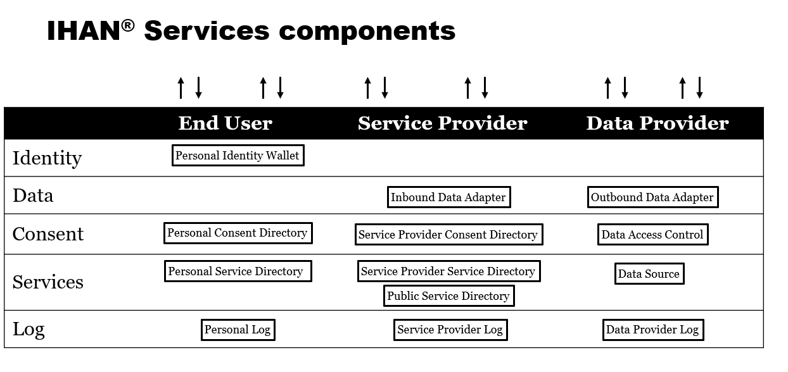

Project deliverables usability from IHAN point of view
How do the components implemented in the project fit into IHAN requirements? For instance, your project may have plenty of deliverables. Which one of those are useful for implementing IHAN?

Project participants
Which organizations are involved in the project? Please describe project’s participants capabilities within data economy. What is the level of technological expertise of the project/network participants? Please describe how responsibilities are allocated in the project between different participants and how the project/network ensures engagement and commitment.
Please name all the participants of the project including contact information.

Background and demand for the project
What are the main drivers for this project? What kind of global challenges does the project resolve? Is the project based on an on-going project or existing network? Are there any international activities to be mentioned? What kind of improvements the project will generate?

Project execution
Please provide a detailed project plan with goals, resources, organization, schedule, deliverables by milestones etc.

Schedule
What is the schedule for the whole project? How are the project’s workflow and milestones planned?

Deliverables and impact of the project
How does the project bring us closer to human-driven data economy? How does the project implement systemic change in the society? What is the added value for people/citizens? How the change is measured and monitored? What is the new perspective the project generates? How does the project make sure that the deliverables are available for other project, other business areas and what is the scalability of the project? How does the project involve end user of the solutions?

- Commitment to collaborate in IHAN® technical workshops
How does the project ensure the collaboration with other IHAN® pilots and participation in IHAN® technical workshops and IHAN® standardization process? Transfer of intellectual property rights: the applicant is prepared to transfer intellectual property rights to the extent required by the pilot project, for example, in connection with the European wide workshops. This will be discussed in details during the funding agreement negotiations.

Budget and funding plan
Please fill in for each applicant separately.

Prelimanary budget

Type of cost | Applicant 1: estimation (euro) | Applicant n: estimation (euro)
Personnel cost | Klikkaa täyttääksesi
Cost of purchased services | Klikkaa täyttääksesi
Other overhead costs and operating expenses | Klikkaa täyttääksesi
Total | Klikkaa täyttääksesi

Prelimary funding
 | Applicant 1 (euro and %) | Applicant n (euro and %)
Requested funding | Klikkaa täyttääksesi
Other public funding  (including de minimis) | Klikkaa täyttääksesi
Private funding | Klikkaa täyttääksesi
Total | Klikkaa täyttääksesi

Follow up
How is the continuity for the project ensured after funding?

Risks
What are the risks in the project and how are they mitigated?

Communication plan for the project
How is the project prepared for communicating about the outcomes? Please describe main messages, essential stakeholders and channels to be exploited.

